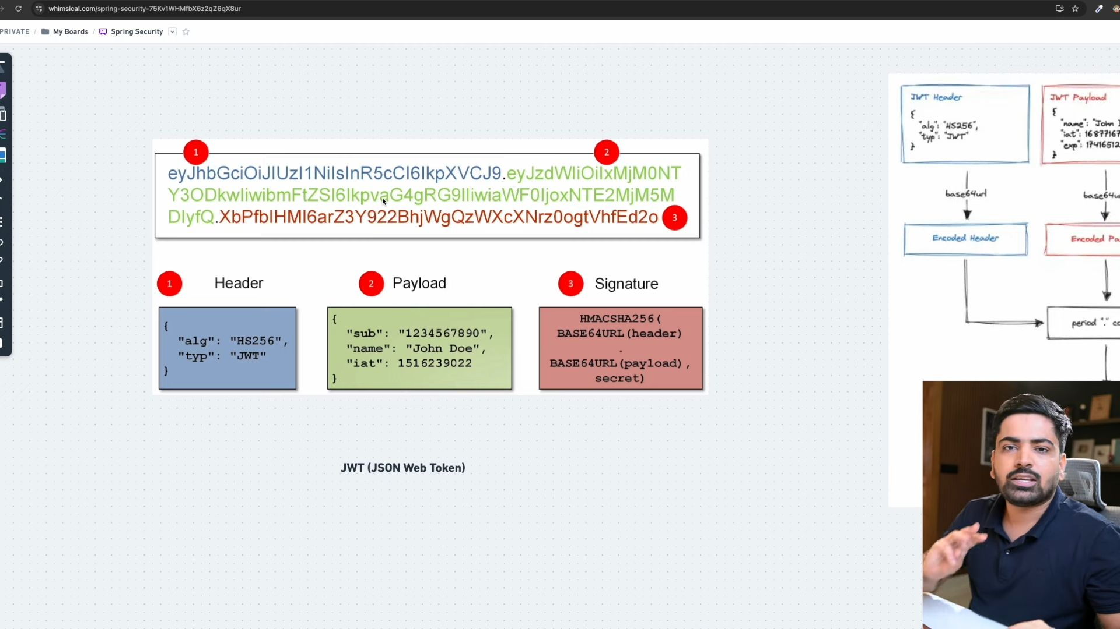
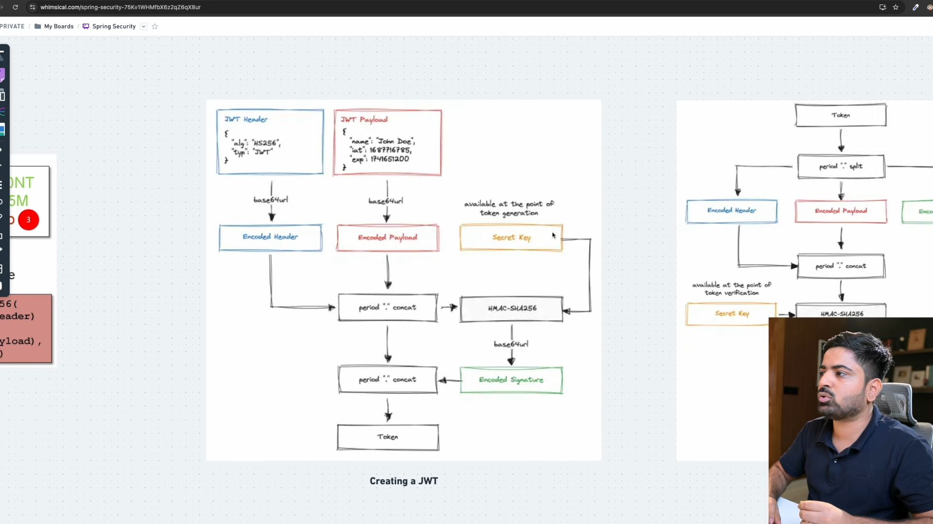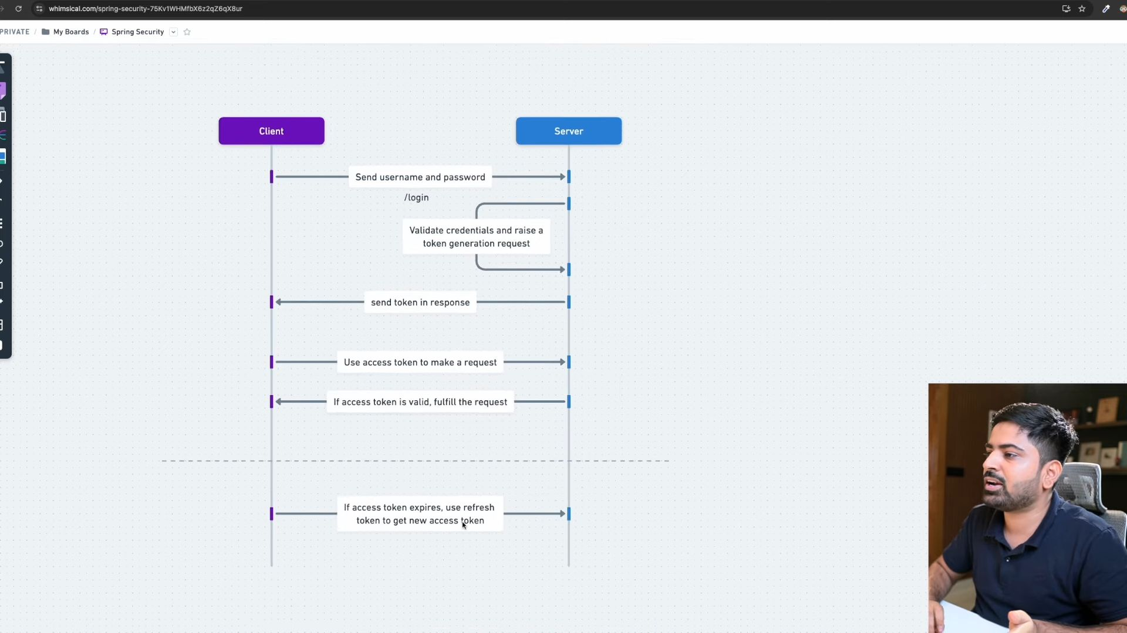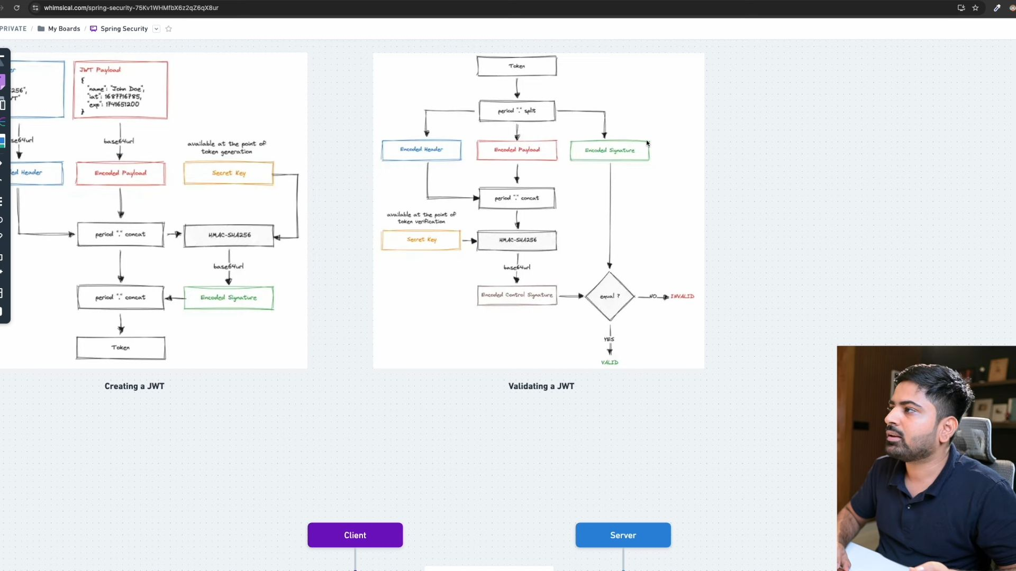
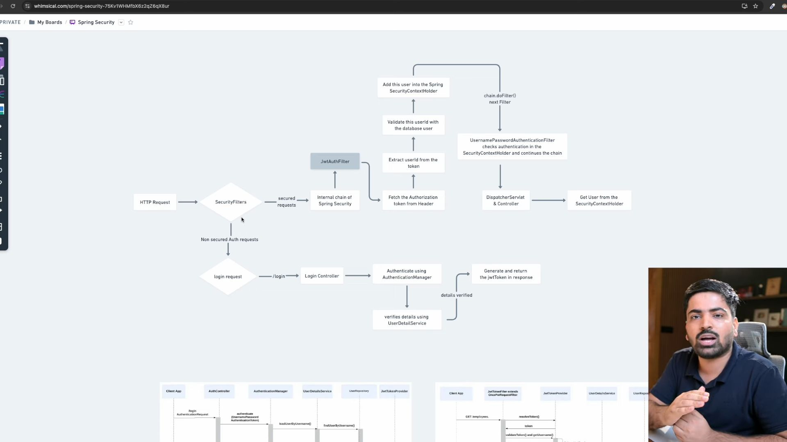
Now I will not use InMemory user for login; I want ki wo database se aye, so for that I need to make an entity class.
Now the DaoAuthentication provider will use this user, not the UserDetails, as we have implemented it. We have to implement its one method, getAuthorization(). We will implement this method when doing authorization. Right now we are only focusing on authentication.
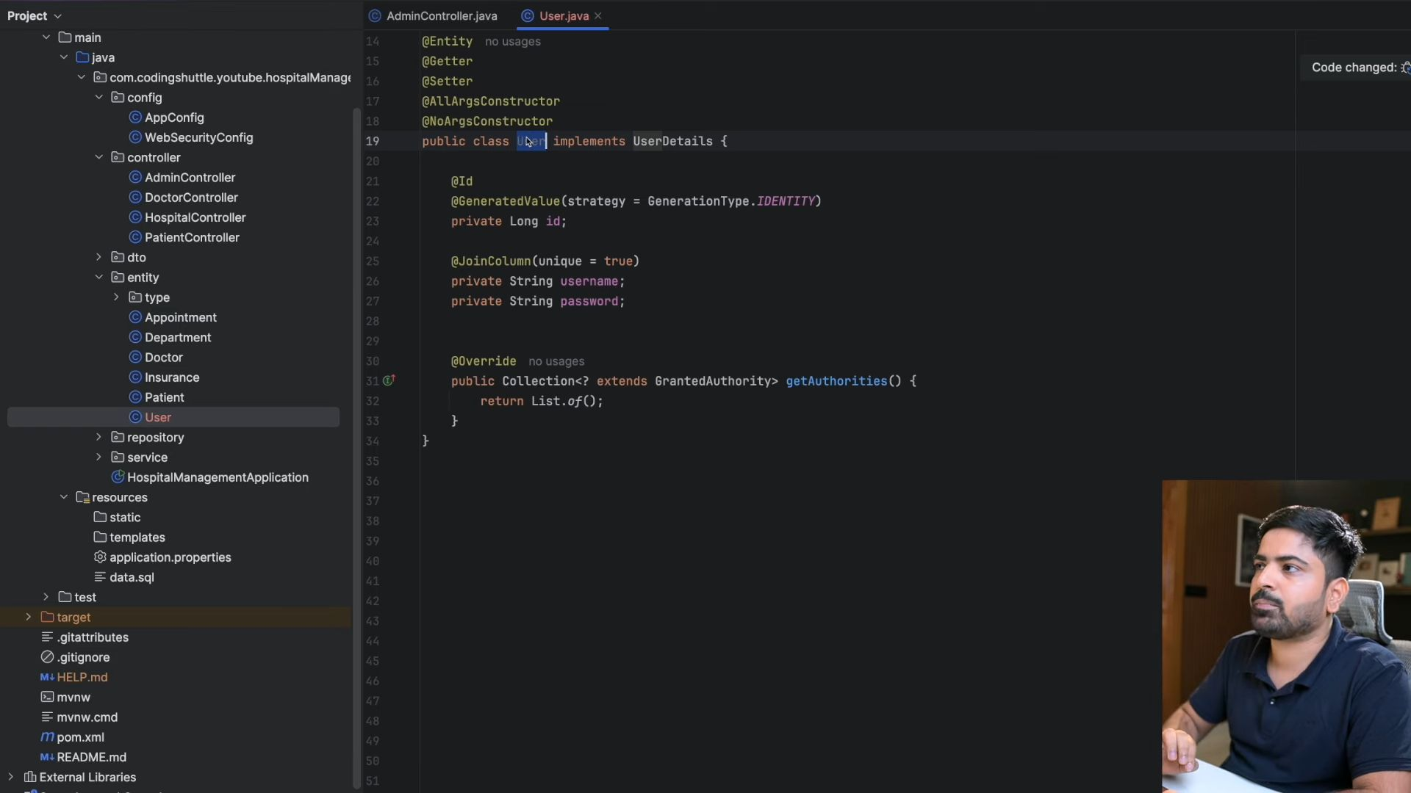
Abhi bhi jo Dao authentication provider Hai, vah in-memory user details service ko use karne wala hai because Humne Bean hi Usi Ka banaya hai.
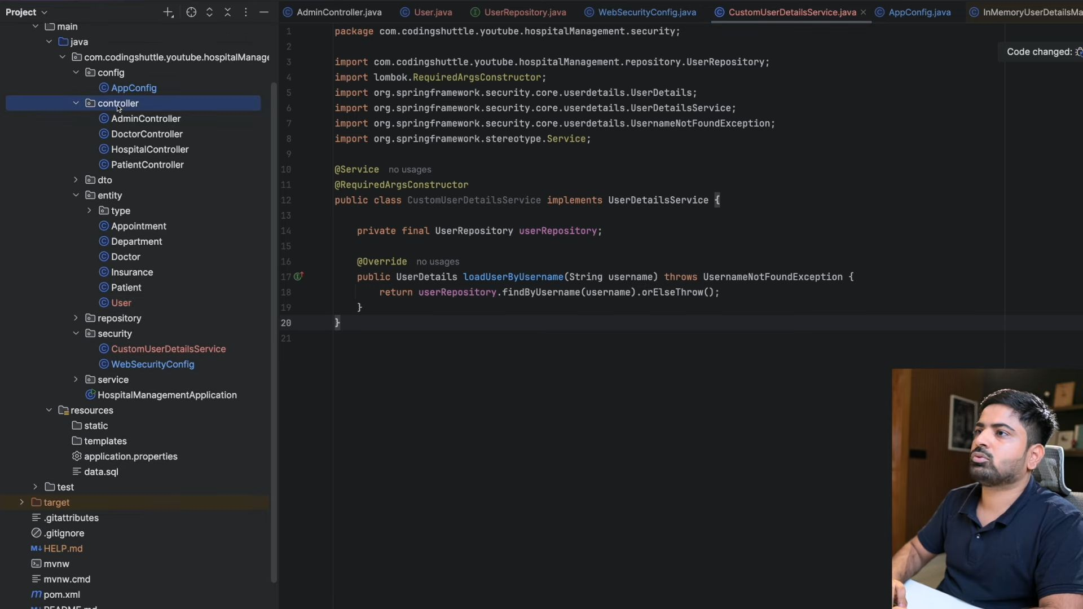
Humne inka session storage and csrf bhi nhi chaheye.
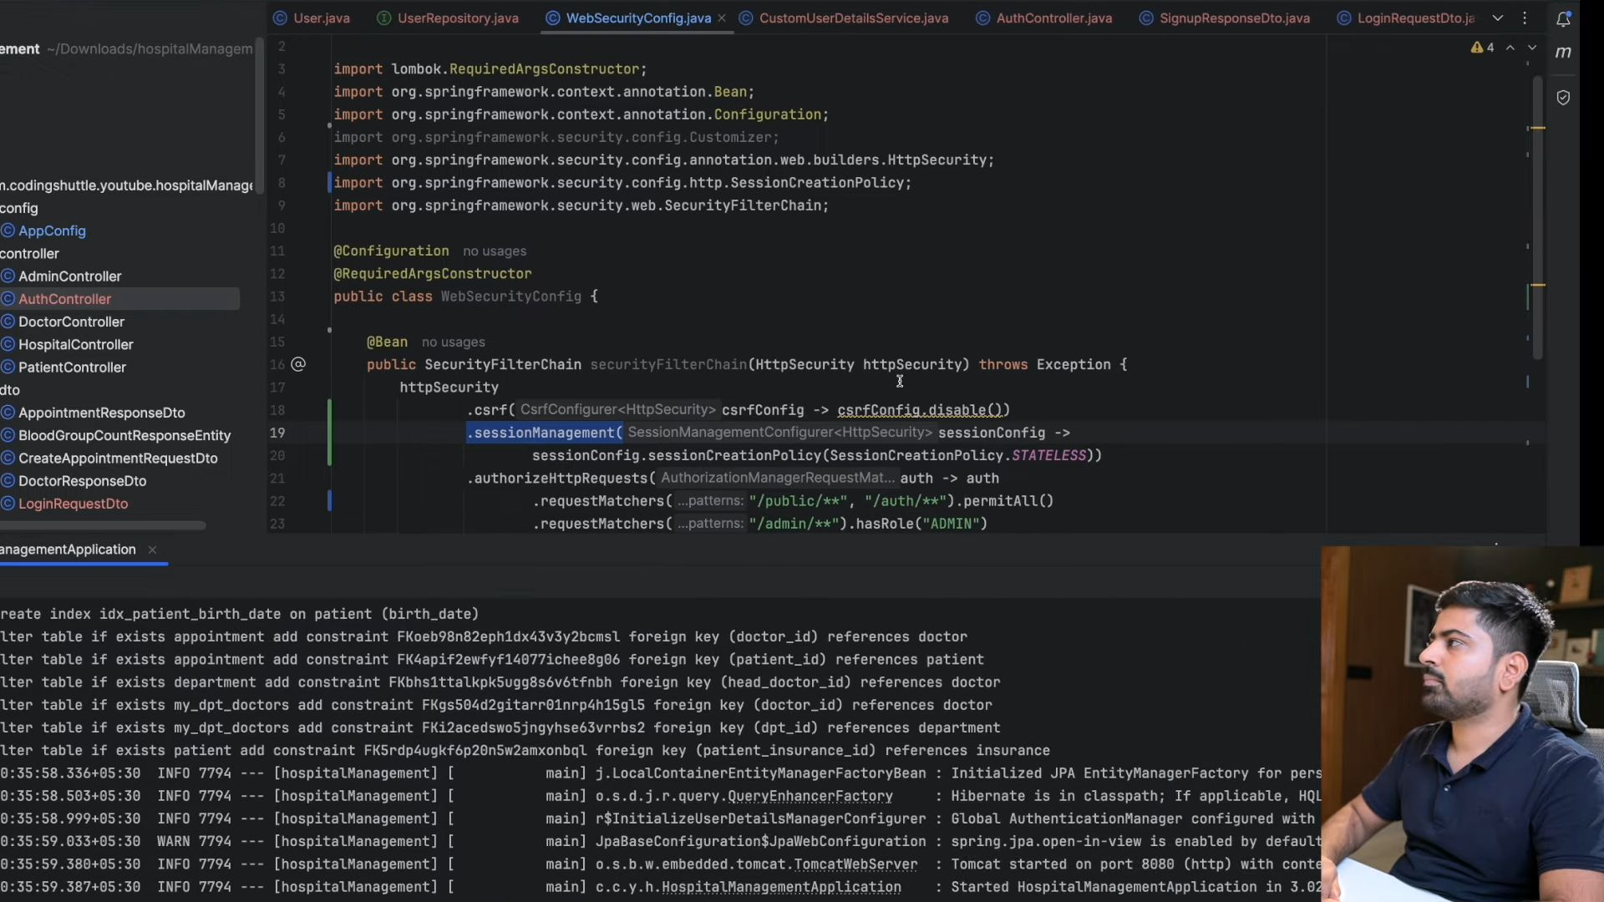
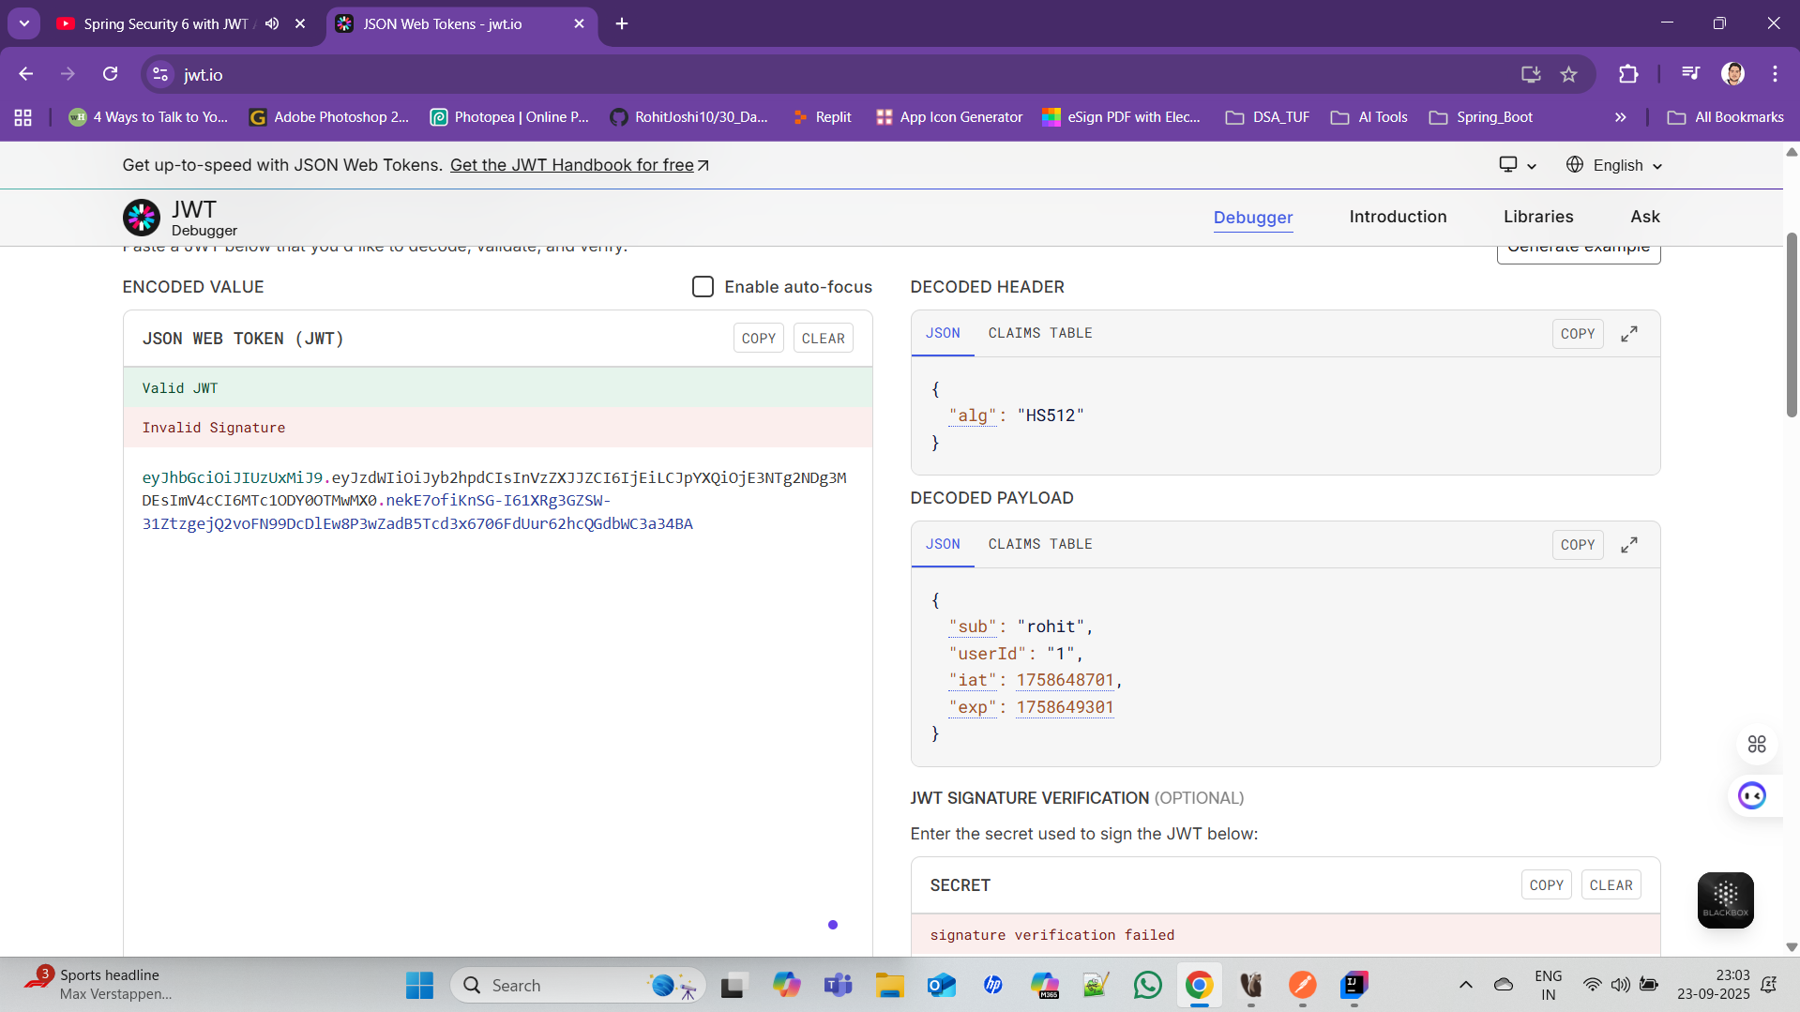
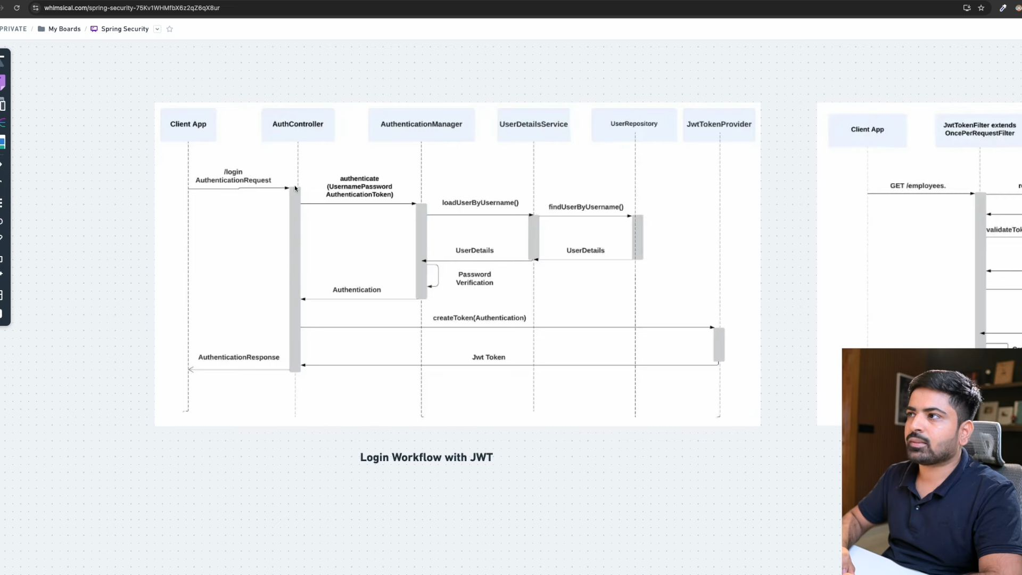
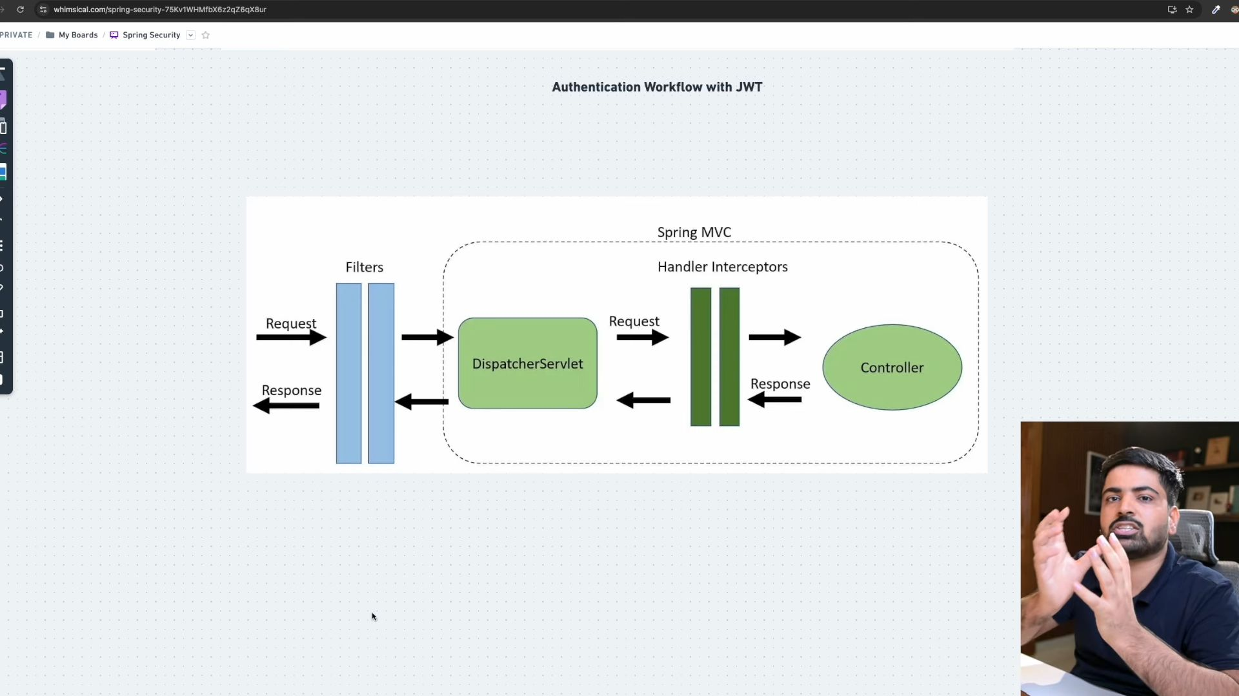
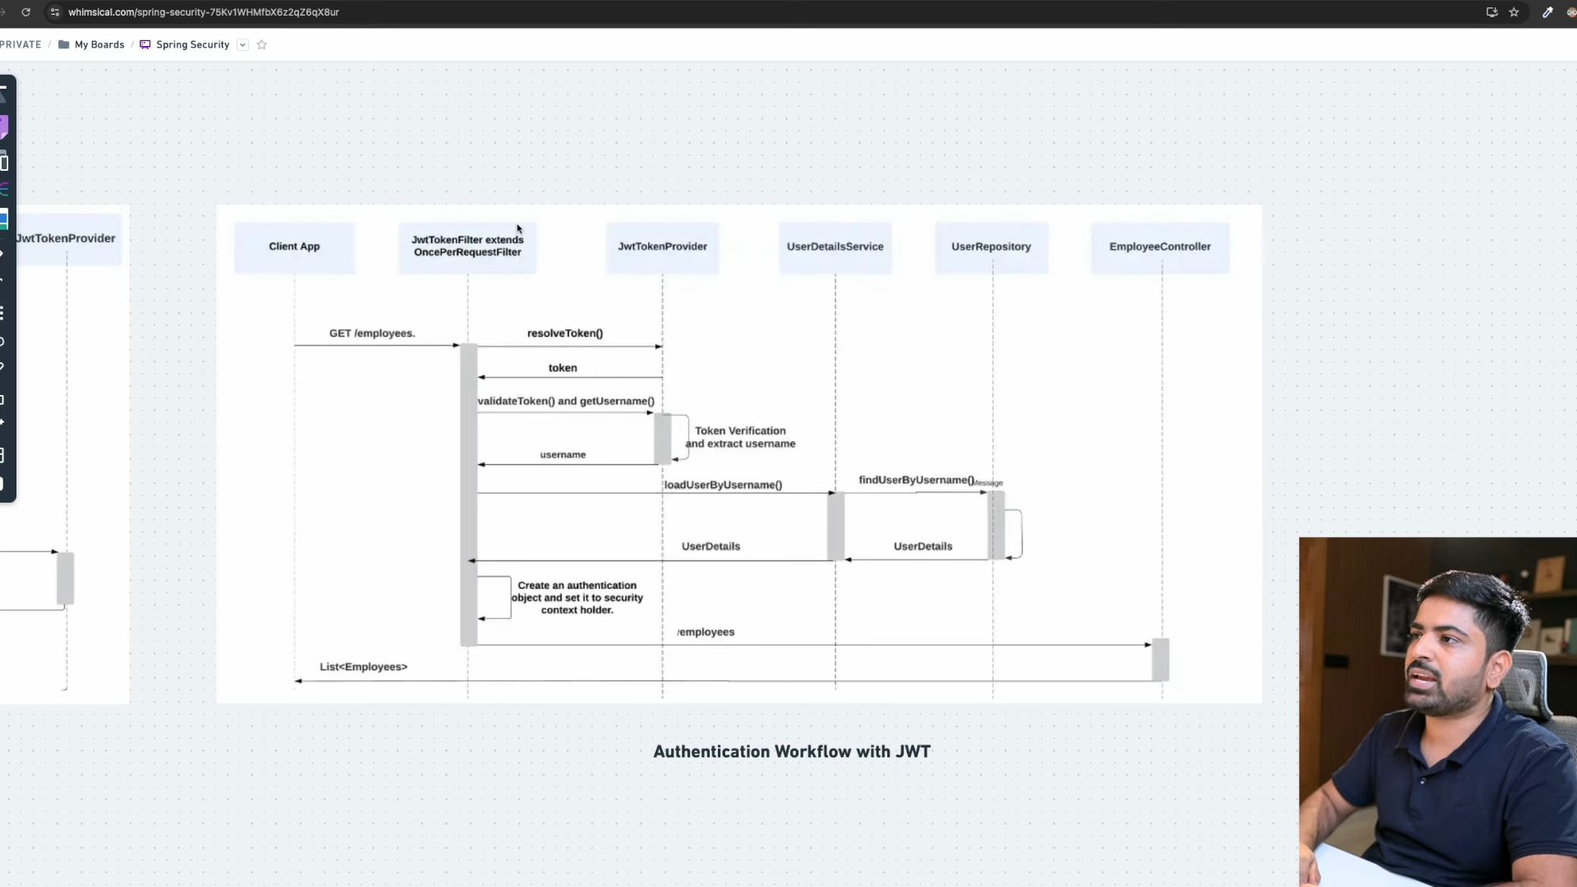Now we will create filter to authenticate requests.
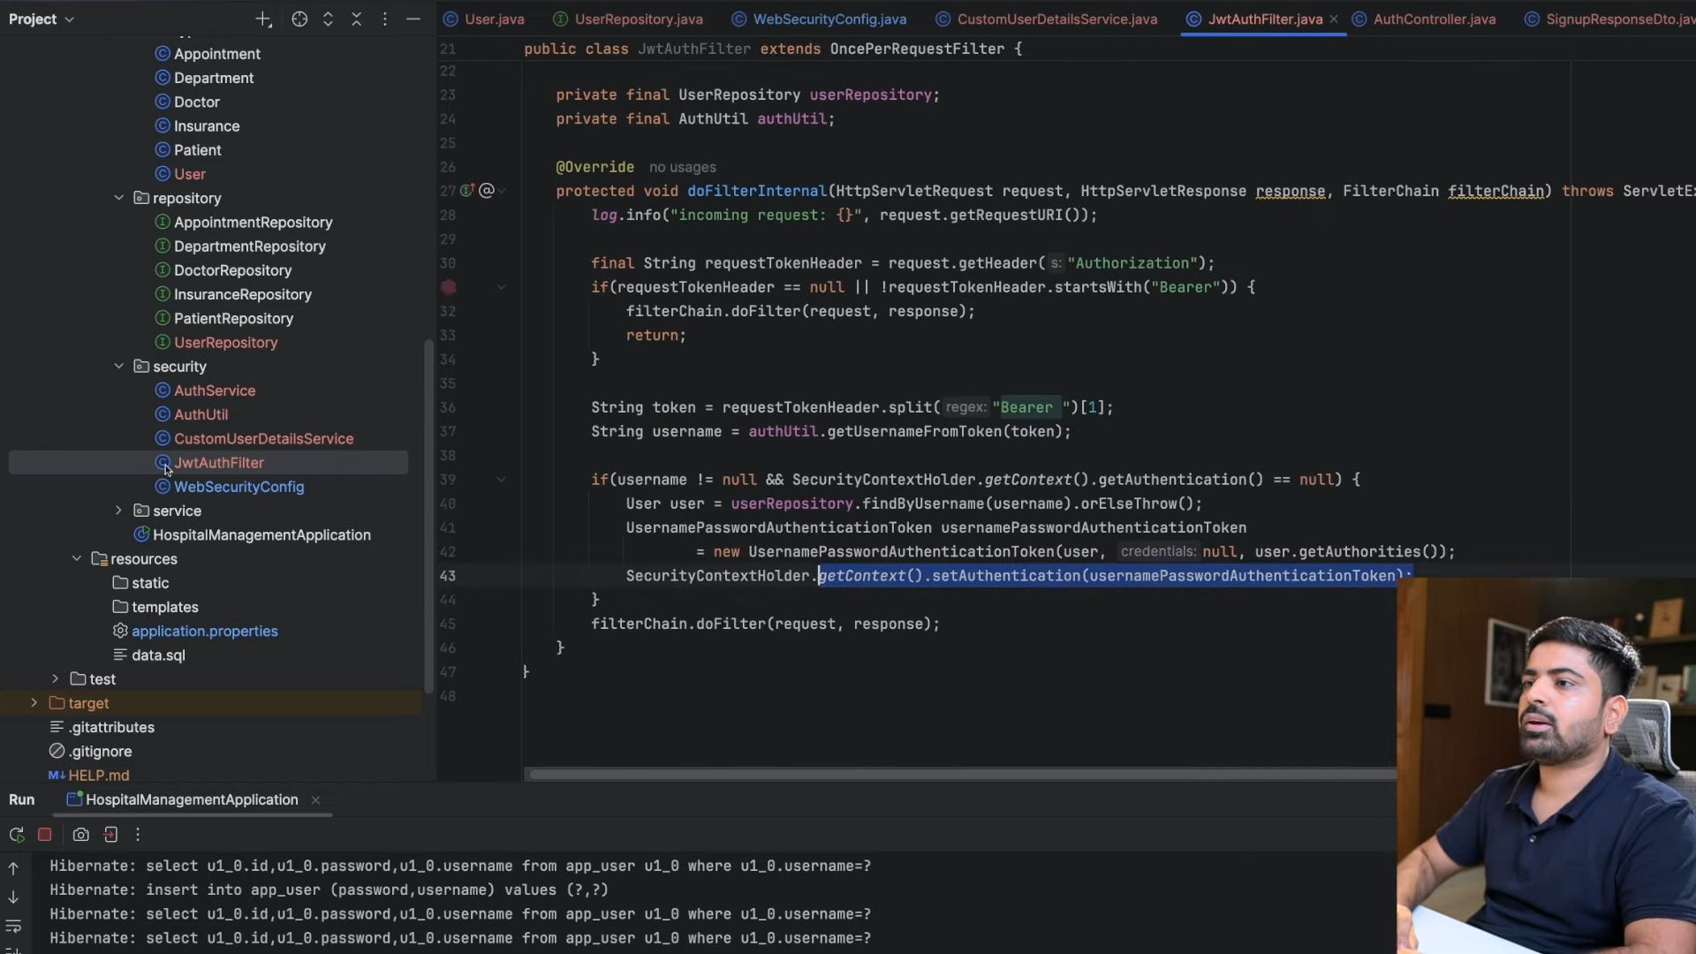
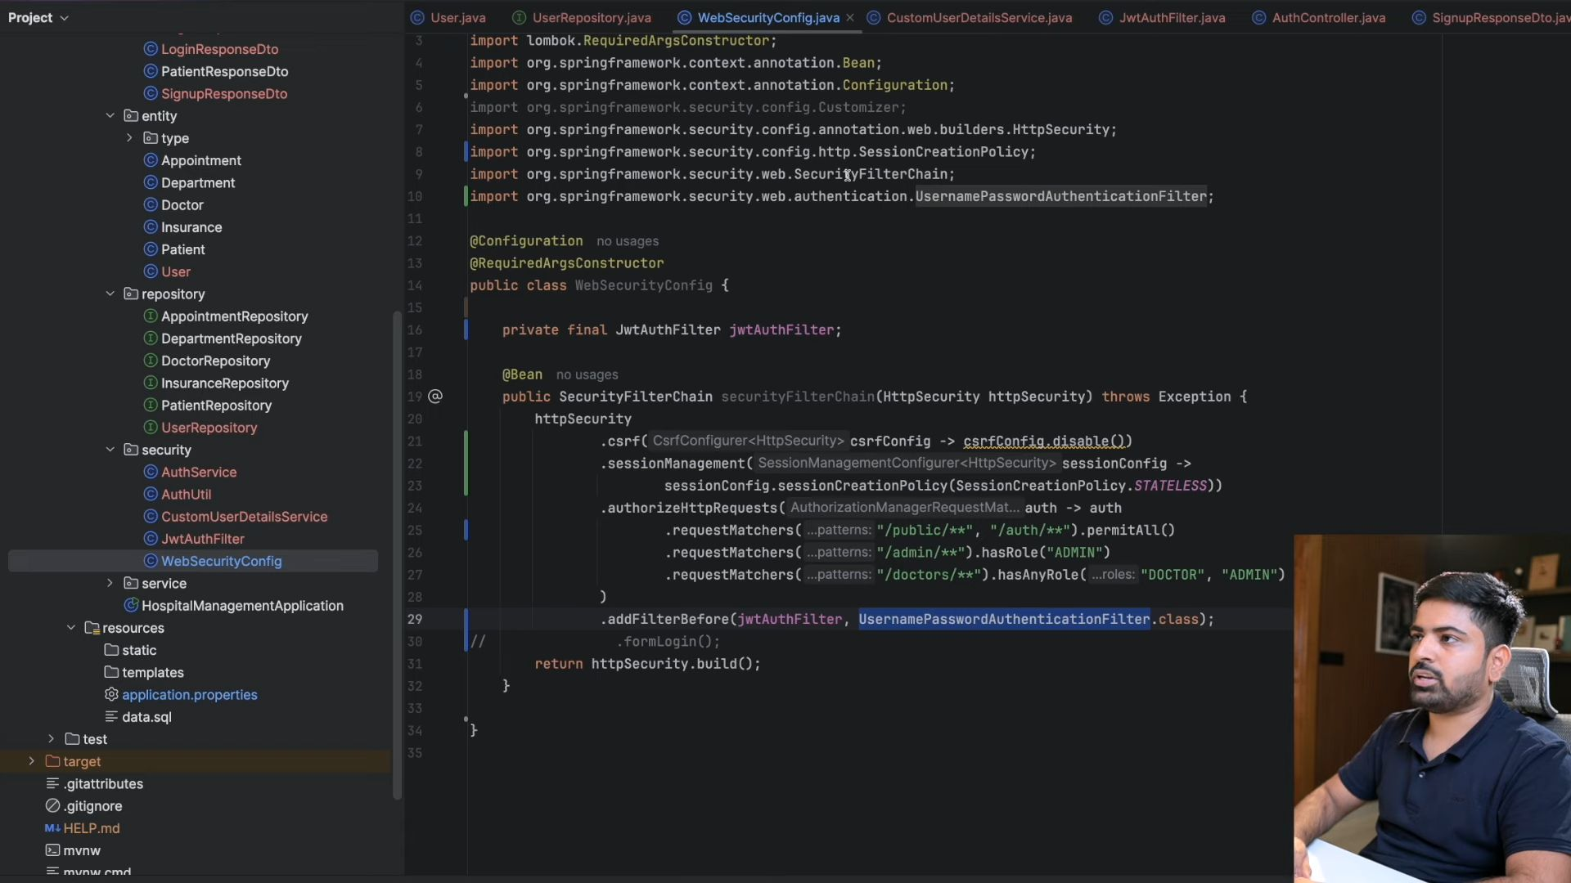
You also need to do proper error handling and for that in spring boot you have global error handling.
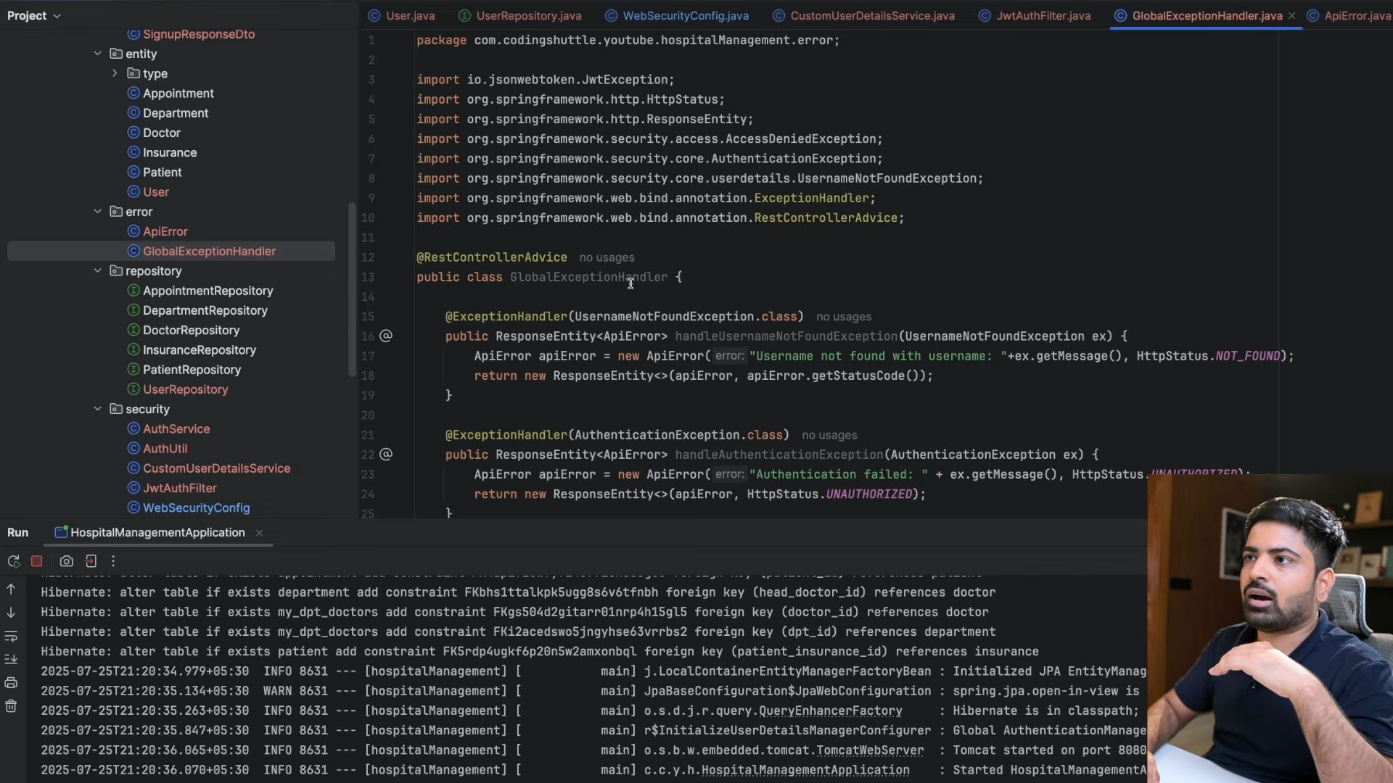
Ab jaise JWT mai koi error aya but wo handle ni hua global exception handler mai because wo abhi controller se agge ni badha wo fiter chain mai he error aa gya so uske liye hum ese kr skte hai handle exception.
